WEEK 2 INTERNSHIP REPORT
FIRMWARE DEVELOPMENT FOR AN 8051-BASED MOTOR CONDITION MONITORING SYSTEM
Submitted by: Soumyaa Shriniwas Satham
Internship Domain: Embedded Systems
Project Title: 8051-Based Motor Condition Monitoring System
Microcontroller: AT89C51 / 8051-compatible microcontroller
Programming Language: Embedded C
Software Tools: Keil µVision and Proteus Design Suite
Reporting Period: Week 2
Submission Date: 11/10/2026

ACKNOWLEDGEMENT
I would like to express my sincere gratitude to the internship organization for providing me with the opportunity to work on an embedded systems project. This internship task has helped me understand the practical aspects of firmware development, microcontroller programming, compilation, and simulation.
I am thankful for the technical resources and learning opportunities that supported the development of the 8051-Based Motor Condition Monitoring System. Working with Keil µVision and Proteus has helped me understand how embedded C programs interact with microcontroller input and output pins.
I would also like to acknowledge the importance of systematic programming, circuit design, and testing in developing reliable embedded applications. This report presents the firmware development process, the program logic, the compilation procedure, and the planned verification of the simulated system.

ABSTRACT
The 8051-Based Motor Condition Monitoring System is an embedded systems project designed to demonstrate the monitoring of simulated motor warning conditions using an 8051-compatible microcontroller. Motors are widely used in industrial machinery, manufacturing equipment, pumps, fans, and automation systems. Monitoring parameters associated with motor operation can help identify abnormal conditions and provide an early warning to an operator.
The objective of this project is to develop firmware that responds to two digital warning inputs representing temperature-related and vibration-related conditions. The firmware processes these inputs and controls three output indicators: a green LED, a red LED, and a buzzer. The green LED indicates the normal simulated condition, while the red LED and buzzer indicate that at least one warning input is active.
The firmware is developed using Embedded C in Keil µVision. The source code is compiled to generate a HEX file, which can be loaded into an AT89C51-compatible microcontroller model in Proteus. The simulation environment enables the relationship between input signals and output responses to be examined without requiring physical sensors or a real motor.
This report explains the system requirements, hardware and software configuration, firmware implementation, compilation process, simulation integration, and verification procedure. It also identifies the limitations of the current simulation and opportunities for future development.
Keywords: 8051 microcontroller, AT89C51, Embedded C, Keil µVision, Proteus, firmware development, motor monitoring, digital inputs, LED indicators, buzzer.

1. INTRODUCTION
1.1 Introduction to Embedded Systems
An embedded system is an electronic system designed to perform a specific function using a combination of hardware and software. It commonly includes a microcontroller, input devices, output devices, memory, and firmware. Embedded systems are used in industrial automation, consumer electronics, automotive systems, medical devices, communication equipment, and monitoring applications.
A microcontroller acts as the main processing unit of an embedded system. It reads input signals, executes instructions stored in its program memory, and controls output devices according to the programmed logic. Unlike a general-purpose computer, a microcontroller-based system is generally designed for a specific task.
Firmware is the software programmed into a microcontroller to control its operation. Firmware development includes understanding system requirements, assigning input and output pins, writing source code, compiling the program, generating the required machine-code file, and testing the resulting system.
1.2 Introduction to Motor Condition Monitoring
Electric motors are essential components in industrial and domestic applications. Their operation can be affected by several conditions, including excessive temperature, mechanical vibration, bearing wear, imbalance, misalignment, and electrical faults.
Monitoring motor-related parameters can help operators identify abnormal operating conditions. In a practical monitoring system, sensors measure physical parameters and provide signals to a controller. The controller processes the signals and activates indicators or protective actions when a predefined threshold is exceeded.
The project presented in this report demonstrates the basic monitoring logic through a simulated embedded system. Instead of connecting physical temperature and vibration sensors, the system uses two digital input signals to represent warning conditions. This approach makes it possible to develop and test the firmware before implementing actual sensors.
1.3 Project Overview
The project uses an AT89C51-compatible 8051 microcontroller model. The firmware is written in Embedded C using Keil µVision, and Proteus is used to represent the microcontroller circuit and simulate input and output behaviour.
The system contains two inputs:
- A temperature warning input.
- A vibration warning input.
It also contains three outputs:
- A green LED for the normal simulated condition.
- A red LED for a warning condition.
- A buzzer for an audible warning indication.
The firmware continuously checks the input signals. If both inputs are LOW, the system indicates the normal condition. If either input is HIGH, the system activates the warning indicators.
The project focuses on the development and simulation of firmware rather than the construction of a complete industrial motor protection device.

2. PROJECT BACKGROUND AND PROBLEM STATEMENT
2.1 Background
In industrial applications, motors may operate for extended periods under different mechanical and electrical loads. Abnormal temperature and vibration can indicate that a motor requires inspection or maintenance. Early warning mechanisms can help operators investigate potential problems before they become more serious.
A basic embedded monitoring system can demonstrate how a microcontroller processes condition signals and produces warning outputs. This project uses a simplified digital-input model to understand the control logic behind such systems.
The AT89C51 is a member of the classic 8051 microcontroller family. It provides digital input/output ports that can be configured for simple control applications. These ports allow the firmware to read the simulated warning inputs and operate the output indicators.
2.2 Problem Statement
The purpose of this project is to develop a simple firmware-based monitoring system that responds to simulated temperature and vibration warning signals. The system must continuously evaluate both inputs and provide clear visual and audible indications according to the input conditions.
The firmware must distinguish between a normal condition and a warning condition. It should activate the green LED when neither warning input is active and activate the red LED and buzzer when one or both warning inputs are active.
The program should be straightforward, understandable, and suitable for testing in a circuit simulation environment. The implementation should also demonstrate the complete basic firmware workflow, including source-code development, compilation, HEX file generation, and integration with the microcontroller model.
2.3 Proposed Solution
The proposed solution uses an 8051-compatible microcontroller programmed in Embedded C. Two digital inputs represent the warning conditions. The firmware reads these inputs continuously and uses conditional statements to determine the appropriate output state.
The program is developed in Keil µVision and compiled to generate a HEX file. This file is then selected in the microcontroller properties in Proteus. Digital logic inputs are used to test the different combinations, and the LED and buzzer outputs are observed during simulation.
This method provides a controlled environment for evaluating the firmware logic and understanding the relationship between software instructions and hardware outputs.

3. OBJECTIVES AND SCOPE
3.1 Objectives
The primary objectives of this internship task are:
- To understand the basic architecture and digital input/output operation of the 8051 microcontroller.
- To translate the system requirements into a firmware design.
- To develop Embedded C source code for monitoring two digital warning inputs.
- To assign suitable microcontroller pins to the inputs and output indicators.
- To compile the firmware using Keil µVision.
- To generate the HEX file required for microcontroller simulation.
- To integrate the firmware with an AT89C51-compatible model in Proteus.
- To examine the system response under normal and warning input conditions.
- To document the firmware development process and verification procedure.
- To identify limitations and possible improvements for future versions.
3.2 Scope of the Project
The current project covers basic digital input monitoring, conditional processing, output control, and simulation-based firmware verification. It demonstrates how an embedded C program can control multiple output devices based on input conditions.
The project includes the following activities:
- Defining system inputs and outputs.
- Preparing the firmware logic.
- Writing and compiling Embedded C code.
- Generating a HEX file.
- Configuring the microcontroller model in Proteus.
- Testing the simulated input combinations.
- Recording observations and documenting the implementation.
3.3 Limitations of the Scope
The current version does not use physical temperature or vibration sensors. The two inputs are simulated digital warning signals, so the program does not measure temperature, vibration amplitude, motor speed, or current.
The system also does not calculate numerical sensor values, maintain historical measurements, transmit data to a remote server, or implement a complete industrial shutdown mechanism.
The project is intended for educational demonstration of microcontroller programming and basic monitoring logic. Its simulation results should not be interpreted as proof of industrial safety or real-motor protection capability.

4. SYSTEM REQUIREMENTS
4.1 Functional Requirements
The firmware must meet the following functional requirements.
FR1: Temperature warning input
The system must read a digital input representing a temperature warning condition.
FR2: Vibration warning input
The system must read a second digital input representing a vibration warning condition.
FR3: Normal condition indication
When both warning inputs are LOW, the firmware must activate the green LED and deactivate the red LED and buzzer.
FR4: Warning condition indication
When either warning input is HIGH, the firmware must deactivate the green LED and activate the red LED and buzzer.
FR5: Continuous monitoring
The firmware must continuously evaluate the input conditions while the program is running.
FR6: Combined warning conditions
When both warning inputs are HIGH, the system must continue to indicate a warning condition.
FR7: Firmware compilation
The source code must compile successfully in the selected Keil 8051 development environment and produce a HEX file for simulation.
4.2 Non-Functional Requirements
The project should satisfy the following non-functional requirements:
- Simplicity: The source code should be understandable and easy to maintain.
- Readability: Meaningful identifiers and comments should explain the function of each input and output.
- Responsiveness: The program should respond to changes in the digital inputs during simulation without unnecessary delay.
- Consistency: The output indicators should follow the defined input-output logic.
- Testability: Each combination of digital inputs should be independently testable.
- Portability: The firmware should use standard 8051-compatible constructs supported by the selected Keil C compiler.
- Documentation: The project should include the source code, build information, circuit diagram, and test observations.
4.3 Hardware Requirements
Component | Quantity | Purpose
AT89C51-compatible microcontroller | 1 | Executes the firmware
Logic-state input controls | 2 | Simulate warning inputs
Green LED | 1 | Indicates the normal condition
Red LED | 1 | Indicates a warning condition
Buzzer | 1 | Provides audible warning
220-ohm resistors | 2 | Limit LED current in the simulated circuit
Crystal oscillator | 1 | Provides the microcontroller clock
33 pF capacitors | 2 | Support the crystal circuit
Reset components | As required | Provide power-on reset behaviour
5 V supply and ground | As required | Provide circuit power connections
The component quantities describe the planned simulation circuit. The exact circuit should be checked against the final Proteus schematic.
4.4 Software Requirements
Keil µVision: Used to create, edit, compile, and build the Embedded C firmware.
8051 C compiler: Converts the source code into machine-code output suitable for the selected microcontroller family.
Proteus Design Suite: Used to create the circuit schematic, load the generated HEX file, simulate digital inputs, and observe output indicators.
Microsoft Word: Used to prepare the internship report and organize screenshots, tables, and technical explanations.
GitHub: Used to store and share the project source code, documentation, and relevant project files.

5. SYSTEM ARCHITECTURE AND DESIGN
5.1 System Architecture
The system is divided into three primary sections: input, processing, and output.
The input section consists of two digital signals. The first represents a temperature warning, and the second represents a vibration warning. In the simulation, the signals are controlled using logic-state components.
The processing section contains the AT89C51-compatible microcontroller. The firmware reads both input signals and evaluates them using a logical OR condition. If either input is active, the program enters the warning state.
The output section consists of a green LED, a red LED, and a buzzer. The outputs communicate the current system state to the user.
Figure 1: System Block Diagram
[Insert your system block diagram image here.]
The conceptual flow of the system is:
Temperature warning input ─┐
Vibration warning input ───┴──> AT89C51 microcontroller running Embedded C firmware
AT89C51 output pins ──> Green LED, Red LED, and Buzzer
The input signals are processed by the firmware, which controls the output indicators according to the predefined conditions.
5.2 Input Design
Two digital inputs are assigned to Port 1 of the microcontroller.
- P1.0 is assigned to the temperature warning input.
- P1.1 is assigned to the vibration warning input.
A LOW input represents an inactive warning signal, while a HIGH input represents an active warning signal. This active-HIGH convention is used consistently in the firmware and the proposed simulation.
The inputs are simulated using logic-state components in Proteus. These components make it possible to change input levels during execution without connecting physical sensors.
The simulated signals represent the output of a hypothetical sensor-processing stage. In a practical system, sensors and appropriate signal-conditioning circuits would be required to determine whether actual temperature or vibration exceeds a defined threshold.
5.3 Output Design
The output indicators are connected to Port 2.
- P2.0 controls the green LED.
- P2.1 controls the red LED.
- P2.2 controls the buzzer signal.
During the normal simulated condition, the green LED is activated and the red LED and buzzer are deactivated.
During a warning condition, the green LED is deactivated and both warning outputs are activated.
Current-limiting resistors should be used in series with the LEDs. For a physical implementation, the buzzer may require a transistor driver rather than direct connection to the microcontroller pin. Actual electrical ratings must be checked before constructing a physical circuit.
5.4 Input-Output Mapping
Signal | Microcontroller pin | Function
Temperature warning | P1.0 | Digital input
Vibration warning | P1.1 | Digital input
Green LED | P2.0 | Normal-state indication
Red LED | P2.1 | Warning indication
Buzzer | P2.2 | Audible warning signal
The pin assignments must match the actual Proteus circuit. If the schematic uses different pins, both the firmware and the documentation must be updated accordingly.
5.5 Control Logic
The firmware uses a logical OR operation to determine whether a warning condition exists.
The logical expression is:
Warning = Temperature Warning OR Vibration Warning
If the expression evaluates to true, the warning indicators are activated. If the expression evaluates to false, the system displays the normal state.
This logic provides a simple method of combining two independent warning conditions. It also reduces code complexity because the program does not need separate warning-handling routines for the two inputs.

6. HARDWARE COMPONENTS AND SOFTWARE TOOLS
6.1 AT89C51 Microcontroller
The AT89C51 is an 8051-family microcontroller used for executing the control program. Its digital input/output ports enable communication with external signals and indicators.
In this project, Port 1 reads the two warning inputs, while Port 2 controls the output indicators. The firmware continuously checks the inputs and updates the outputs based on the defined conditions.
The microcontroller model used in Proteus must be compatible with the generated firmware. If the exact AT89C51 model is unavailable, an appropriate 8051-compatible device may be used for the simulation, provided the selected model supports the program and pin configuration.
6.2 Light-Emitting Diodes
LEDs provide visual feedback about the simulated operating condition. The green LED represents normal operation, while the red LED represents a warning.
LEDs are suitable for this demonstration because their states can be observed directly in the simulation. Each LED should have a suitable series resistor to limit current.
6.3 Buzzer
The buzzer provides an audible warning indication when either warning input becomes active. It is controlled by the P2.2 output signal.
In a real hardware design, the buzzer's voltage and current requirements must be considered. A transistor or dedicated driver may be required to prevent excessive current from flowing through the microcontroller output pin.
6.4 Crystal Oscillator
The crystal oscillator provides a clock reference for the microcontroller. The proposed design uses an 11.0592 MHz crystal, with two 33 pF capacitors as specified in the circuit design.
The clock setting in the Proteus microcontroller properties should match the intended oscillator frequency. The exact oscillator requirements should be confirmed against the selected device model.
6.5 Reset Circuit
The reset circuit places the microcontroller into a known starting state when power is applied or a reset is triggered. The circuit should follow the reset requirements of the selected microcontroller.
The reset network shown in the Proteus schematic should be checked to ensure that the reset pin receives the correct startup signal. A circuit that does not reset correctly may prevent the program from starting as expected.
6.6 Keil µVision
Keil µVision is the development environment used to write and compile the Embedded C program. It supports project configuration, source-code editing, build output, and generation of the firmware file.
The development workflow involves creating a project, selecting the target device, adding the C source file, configuring the output options, and compiling the project.
6.7 Proteus Design Suite
Proteus is used to create and simulate the microcontroller circuit. It provides components such as the microcontroller, digital logic inputs, LEDs, resistors, and buzzer models.
The generated HEX file is loaded into the microcontroller component. The simulation can then be started to observe how the outputs respond to the input states.

7. FIRMWARE DEVELOPMENT
7.1 Development Approach
The firmware was designed using a simple polling method. In polling, the program repeatedly reads the input signals and checks whether a defined condition has occurred.
This method is suitable for the current project because the system has only two digital inputs and three outputs. The program does not require interrupt handling, complex scheduling, or an operating system.
The firmware uses meaningful identifiers for the input and output pins. This improves readability and makes it easier to understand the purpose of each signal.
7.2 Source-Code Organization
The source code contains the following logical sections:
- Header inclusion.
- Input pin definitions.
- Output pin definitions.
- Initialization of output indicators.
- Continuous input monitoring.
- Conditional control of the indicators.
The REGX51.H header provides register and port definitions for the 8051-family device supported by the compiler. The sbit declarations assign readable names to individual microcontroller pins.
7.3 Firmware Logic
At program startup, the firmware initializes the output indicators. It then enters an infinite loop.
Within the loop, the program checks whether either the temperature warning input or the vibration warning input is HIGH. If either condition is true, the program turns off the green LED and activates the red LED and buzzer.
If both inputs are LOW, the firmware activates the green LED and deactivates the red LED and buzzer.
The infinite loop ensures that the system continues monitoring the input signals while the microcontroller is running.
7.4 Complete Embedded C Source Code
The following is the firmware used for the simulated monitoring logic. Ensure that this matches the code actually compiled in Keil and the pin connections in Proteus.
#include <REGX51.H>

/* Input pins: simulated warning signals */
sbit TEMP_WARNING = P1^0;
sbit VIB_WARNING = P1^1;

/* Output pins: status indicators */
sbit GREEN_LED = P2^0;
sbit RED_LED = P2^1;
sbit BUZZER = P2^2;

void main(void)
{
/* Initialize output indicators */
GREEN_LED = 0;
RED_LED = 0;
BUZZER = 0;

while (1)
{
/* Check both warning inputs */
if ((TEMP_WARNING == 1) || (VIB_WARNING == 1))
{
/* Warning condition detected */
GREEN_LED = 0;
RED_LED = 1;
BUZZER = 1;
}
else
{
/* No warning condition detected */
GREEN_LED = 1;
RED_LED = 0;
BUZZER = 0;
}
}
}
Figure 2: Firmware Source Code
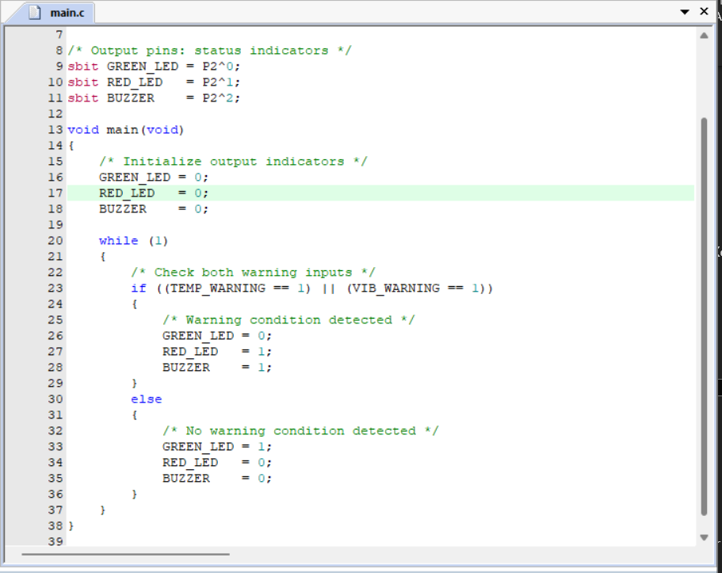
7.5 Explanation of the Code
Header file: REGX51.H provides definitions for the 8051-family registers and ports used by the compiler.
Input declarations: TEMP_WARNING and VIB_WARNING represent the digital inputs connected to P1.0 and P1.1.
Output declarations: GREEN_LED, RED_LED, and BUZZER represent the output signals connected to P2.0, P2.1, and P2.2.
Main function: The main() function is the entry point of the firmware.
Initialization: The program assigns initial values to the output indicators before entering the monitoring loop. The first visible normal-state indication is established by the else branch when both inputs are LOW.
Infinite loop: The while (1) statement continuously executes the input-checking logic.
Conditional statement: The logical OR operator || checks whether at least one warning input is HIGH.
Warning state: If either input is HIGH, the firmware sets the green LED LOW and the red LED and buzzer HIGH.
Normal state: If both inputs are LOW, the firmware sets the green LED HIGH and the red LED and buzzer LOW.
The firmware assumes that the simulated inputs and outputs use active-HIGH logic. The actual circuit must be wired consistently with these assumptions.
7.6 Algorithm
The algorithm for the monitoring system is as follows:
- Start the program.
- Initialize the output indicators.
- Read the temperature warning input.
- Read the vibration warning input.
- Check whether either input is HIGH.
- If either input is HIGH, turn off the green LED and activate the red LED and buzzer.
- Otherwise, activate the green LED and deactivate the red LED and buzzer.
- Repeat the input-checking process continuously.
This algorithm is implemented using a simple conditional statement inside an infinite loop.
7.7 Pseudocode
Algorithm 1: Motor Condition Monitoring
BEGIN

INITIALIZE output indicators

WHILE TRUE DO

READ temperature_warning
READ vibration_warning

IF (temperature_warning = HIGH) OR
(vibration_warning = HIGH) THEN

SET green_LED = OFF
SET red_LED = ON
SET buzzer = ON

ELSE

SET green_LED = ON
SET red_LED = OFF
SET buzzer = OFF

END IF

END WHILE

END

8. COMPILATION AND HEX FILE GENERATION
8.1 Purpose of Compilation
The source code written in Embedded C must be translated into a format that the microcontroller simulation can execute. The compiler checks the source code for syntax and other compilation errors and generates the required program output.
In the Keil development environment, the firmware is built using the configured 8051 target. The HEX file is then used by Proteus to load the program into the microcontroller model.
8.2 Compilation Procedure
The general compilation procedure is:
- Open the project in Keil µVision.
- Confirm that the correct 8051-compatible target is selected.
- Open the C source file and verify the input/output pin definitions.
- Open the target options and enable HEX file generation under the Output settings.
- Save the source code and project configuration.
- Build the project using the Build command or F7.
- Review the build output for errors and warnings.
- Locate the generated HEX file in the configured output directory.
The build output obtained during development reported:
Program Size: data=9.0 xdata=0 code=43
creating hex file from ".\Objects\Motor Conditioning"...
0 Error(s), 0 Warning(s).
This output indicates that the compiler completed the build without reporting compilation errors or warnings. The program-size values describe the resources reported by the compiler for that build.
Compilation success does not by itself prove that the complete circuit works correctly. Simulation testing is required to verify the interaction between the firmware and the circuit.
Figure 3: Successful Keil Build Output
[Insert your actual Keil build output screenshot here.]
8.3 HEX File Generation
The HEX file contains the compiled program in a format commonly used by microcontroller programming and simulation tools.
The project output directory is typically named Objects, but the exact path and filename depend on the project configuration. The generated file should be located using the actual file shown in the project folder.
The filename may be similar to Motor Conditioning.hex, depending on the configured project name and output settings. Confirm the exact filename before selecting it in Proteus.
8.4 Loading the HEX File into Proteus
The HEX file is loaded into the microcontroller component using the following procedure:
- Open the Proteus circuit.
- Double-click the AT89C51-compatible microcontroller.
- Locate the Program File field in the component properties.
- Browse to the generated HEX file.
- Select the correct file and confirm the properties.
- Verify that the configured clock frequency matches the intended crystal frequency.
- Start the simulation and observe the circuit.
If the simulation does not run, check the HEX-file path, microcontroller model, clock setting, reset wiring, power connections, and input/output pin assignments.
Figure 4: Microcontroller Properties with Program File
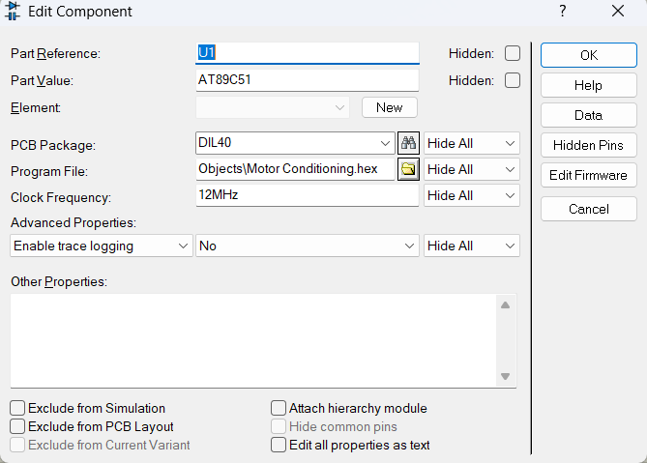
9. PROTEUS INTEGRATION AND TESTING
9.1 Simulation Setup
Proteus is used to integrate the firmware with the microcontroller model and the external circuit components. The simulation includes the microcontroller, digital logic inputs, LEDs, resistors, buzzer, oscillator components, and the required power and reset connections.
The two logic-state components provide controllable input signals. By changing the states of these inputs, the firmware can be evaluated under normal and warning conditions.
The green LED indicates the normal simulated condition. The red LED and buzzer indicate an active warning. The simulation provides a visual method of checking whether the output behaviour corresponds to the programmed logic.
Figure 5: Completed Proteus Circuit
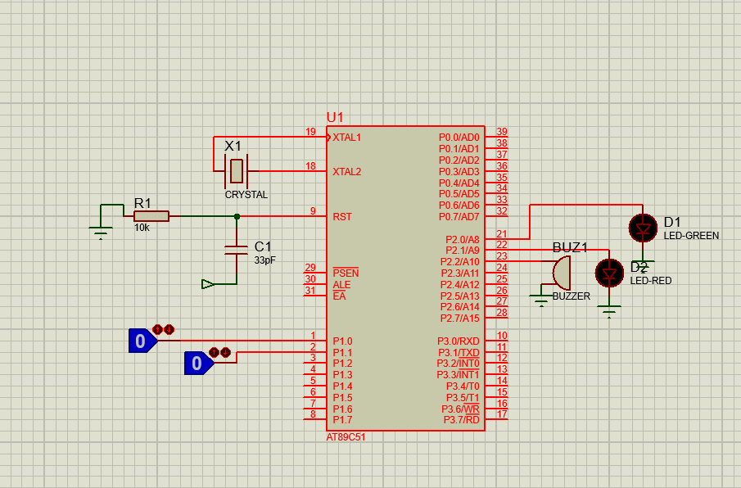
9.2 Input Combinations
There are four possible combinations for two binary inputs. All four combinations should be checked to verify the behaviour of the firmware.
Test case | P1.0 | P1.1 | Expected green LED | Expected red LED | Expected buzzer
TC01 | 0 | 0 | ON | OFF | OFF
TC02 | 0 | 1 | OFF | ON | ON
TC03 | 1 | 0 | OFF | ON | ON
TC04 | 1 | 1 | OFF | ON | ON
The expected behavior is derived from the firmware's logical OR condition. The observed result for each test must be recorded after the simulation is run.
9.3 Test Procedure
The following procedure can be used to perform the verification:
- Load the compiled HEX file into the microcontroller model.
- Start the Proteus simulation.
- Set both logic-state inputs to LOW.
- Observe the green LED, red LED, and buzzer.
- Set the vibration warning input HIGH while keeping the temperature warning input LOW.
- Observe the output indicators.
- Return the vibration input LOW and set the temperature warning input HIGH.
- Observe the output indicators.
- Set both warning inputs HIGH.
- Record the actual output states for all four cases.
The circuit should be checked for incorrect wiring, reversed LED polarity, missing current-limiting resistors, incorrect component properties, and mismatched firmware pin definitions if the observed behaviour differs from the expected results.
9.4 Test Results Record
Complete this table using the actual results from Proteus.
Test case | Expected behaviour | Observed behaviour | Status
TC01: Both inputs LOW | Green ON; red and buzzer OFF | [Enter observed result] | [Pass/Fail]
TC02: Vibration input HIGH | Green OFF; red and buzzer ON | [Enter observed result] | [Pass/Fail]
TC03: Temperature input HIGH | Green OFF; red and buzzer ON | [Enter observed result] | [Pass/Fail]
TC04: Both inputs HIGH | Green OFF; red and buzzer ON | [Enter observed result] | [Pass/Fail]
A test should be marked as passed only when the observed output matches the expected behaviour. If a test fails, document the discrepancy and investigate it before finalizing the report.
9.5 Evidence Collection
Screenshots provide evidence of the implementation and test procedure. The following evidence should be collected from the actual development environment:
- The complete firmware source code in Keil µVision.
- The Keil build output showing the compilation status.
- The microcontroller properties showing the loaded HEX file.
- The complete Proteus circuit.
- The normal simulated state with both inputs LOW.
- A warning state with at least one input HIGH.
- The results of the four input combinations, where practical.
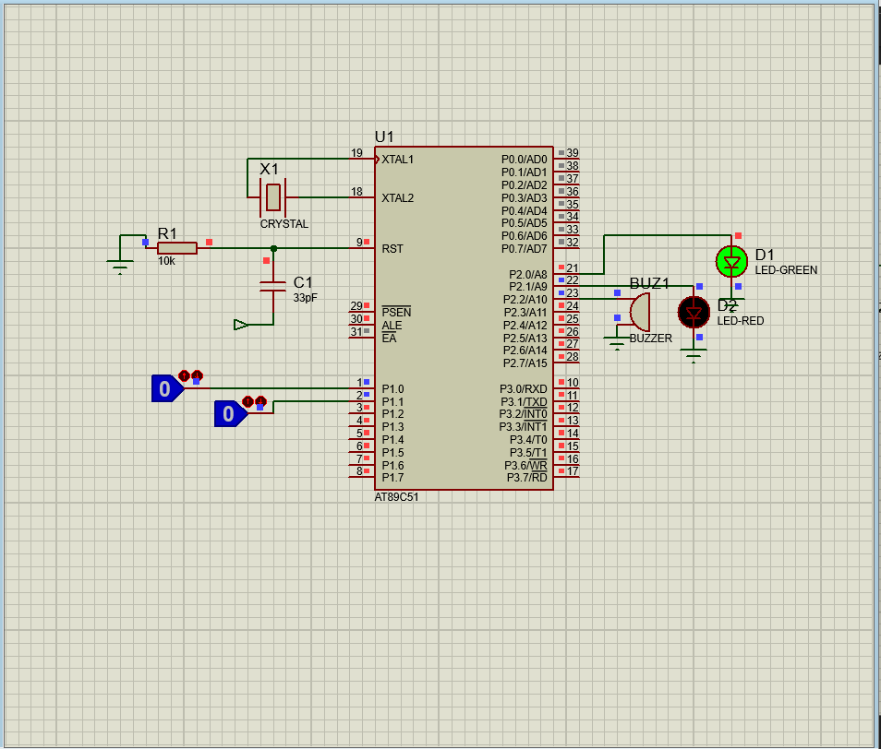
Fig 1
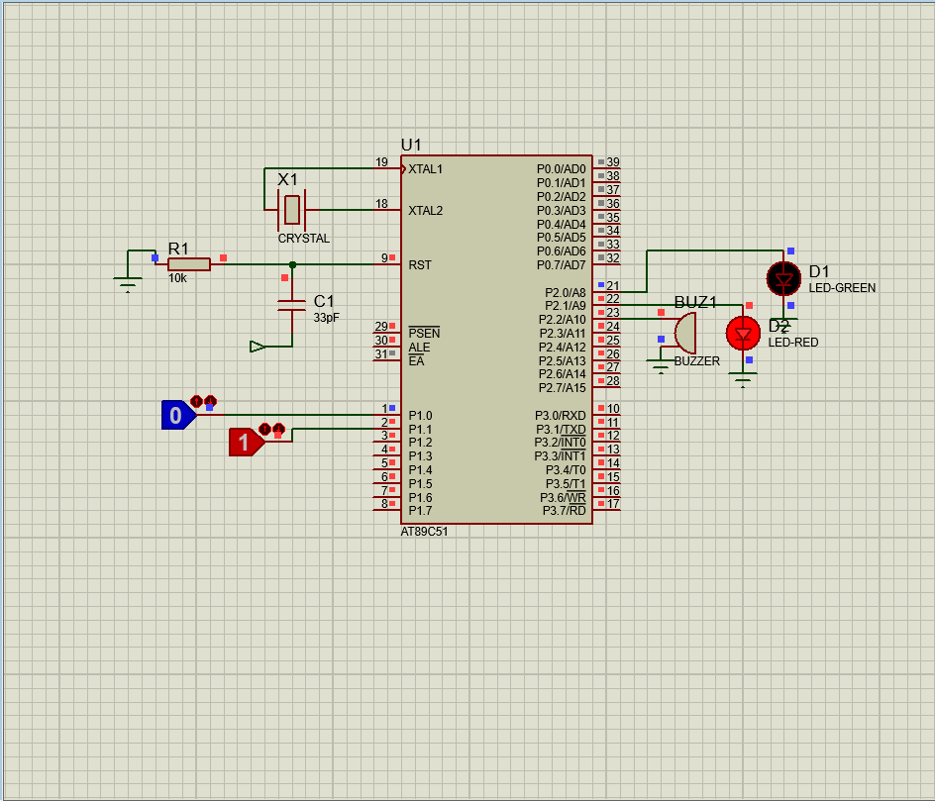
Fig 2
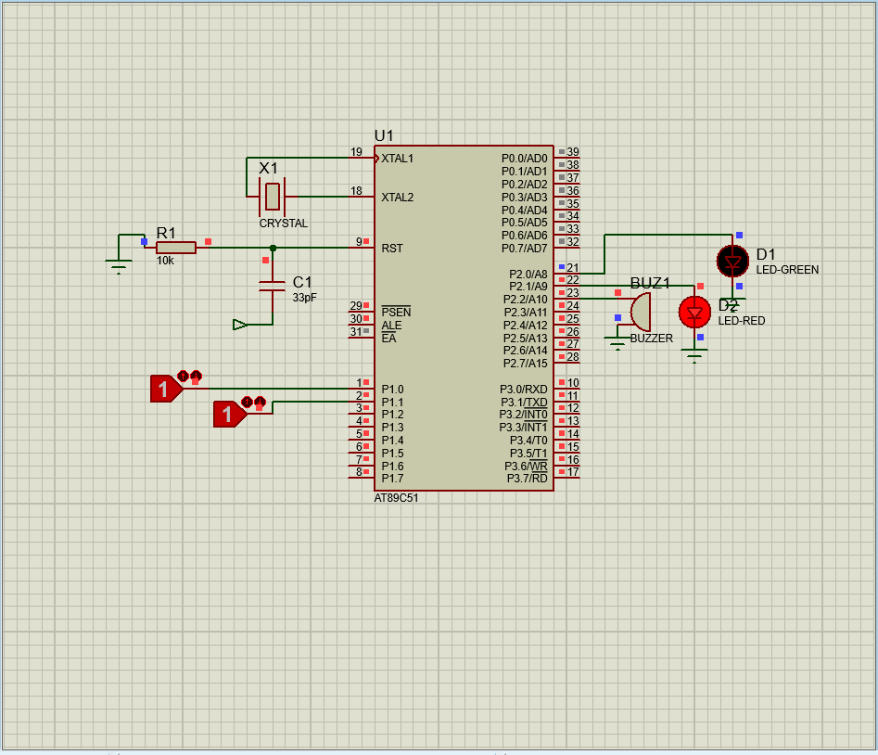
Fig 3
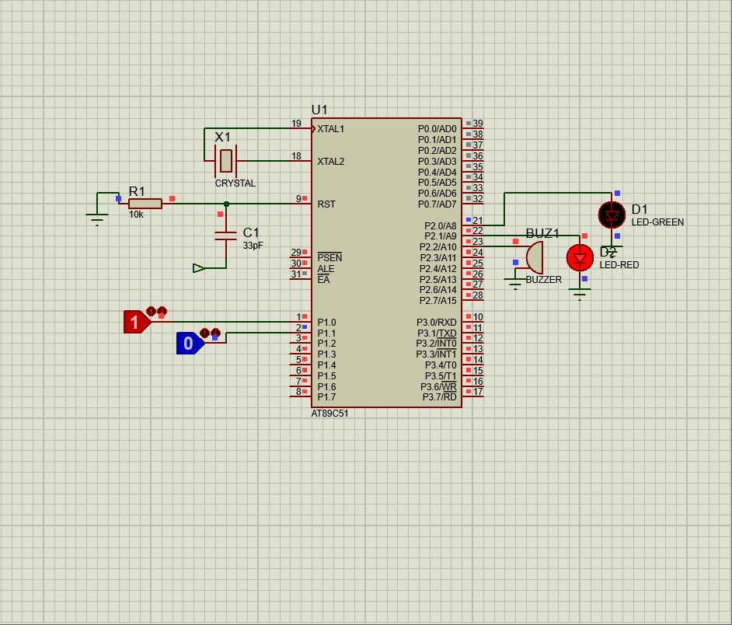
Fig 4
10. RESULTS, LIMITATIONS, AND CONCLUSION
10.1 Development Results
The firmware for the 8051-Based Motor Condition Monitoring System was developed in Embedded C using Keil µVision. The program defines two digital warning inputs and three output indicators. A continuous polling loop evaluates the inputs and controls the outputs according to a logical OR condition.
The Keil build output reported zero errors and zero warnings, and HEX file generation was reported by the build process. This confirms that the source code was compiled successfully in the selected development environment.
The next verification step is to confirm that the HEX file is loaded correctly in Proteus and that all four input combinations produce the expected output states. The final test status should be based on the actual simulation observations documented in Section 9.
10.2 Limitations
The current implementation has several limitations.
First, temperature and vibration are represented by digital warning signals rather than physical sensor measurements. Therefore, the system does not measure actual motor conditions.
Second, the program uses fixed digital input states and does not implement threshold calculations, filtering, calibration, or sensor-fault detection.
Third, the project does not include motor-speed measurement, current monitoring, data logging, wireless communication, or a real motor shutdown circuit.
Finally, simulation verifies the behaviour of the modelled circuit and firmware but does not establish that a physical implementation would operate reliably under industrial conditions.
10.3 Future Scope
The project can be extended by adding a physical temperature sensor and an appropriate vibration sensor. Sensor readings could be processed using thresholds to identify abnormal conditions.
An LCD or OLED display could be added to show the current state and measured values. A data-logging feature could record warning events for later analysis. A communication interface could be incorporated to send status information to a computer or monitoring dashboard.
Additional features could include alarm delay, warning prioritization, sensor-fault detection, and a reset mechanism. If the system is developed for real machinery, its electrical design, protective functions, fault handling, and operating limits would need to be validated before use.
10.4 Skills and Learning Outcomes
This task provides an opportunity to develop practical knowledge in the following areas:
- Understanding the role of a microcontroller in an embedded application.
- Translating system requirements into digital input/output behaviour.
- Writing readable Embedded C code.
- Assigning microcontroller port pins to external components.
- Using conditional statements and logical operators.
- Compiling source code and generating a HEX file.
- Integrating firmware with a simulated microcontroller circuit.
- Preparing structured test cases and recording observations.
- Documenting implementation details and project limitations.
The development process also demonstrates the importance of matching the firmware configuration to the circuit design and validating actual behaviour instead of relying solely on successful compilation.
10.5 Conclusion
The Week 2 task focuses on firmware development for an 8051-Based Motor Condition Monitoring System. The project uses two simulated warning inputs and three output indicators to demonstrate basic embedded control logic.
The firmware was written in Embedded C and compiled using Keil µVision. The build output reported zero errors and zero warnings, and HEX file generation was reported. Proteus provides the environment for integrating the compiled program with the microcontroller model and checking the response to different input conditions.
The implementation demonstrates the basic workflow of embedded firmware development, from defining requirements and writing source code to compilation, integration, and verification. The system remains a simulation-based educational prototype and does not replace a real sensor-based industrial monitoring or protection system.
The final test conclusions should be completed after running all four input combinations and recording the actual observations in the test table. The source code, circuit schematic, screenshots, and report should then be organized for submission and future project development.

11. REFERENCES
- Atmel Corporation, AT89C51 Microcontroller Data Sheet. Refer to the manufacturer documentation corresponding to the device model used.
- Arm Keil, Keil µVision User Documentation. Refer to the documentation for project creation, compilation, and output configuration.
- Labcenter Electronics, Proteus Design Suite Documentation. Refer to the documentation for schematic capture, microcontroller simulation, and component properties.
- Intel, MCS-51 Microcontroller Family Documentation. Refer to the applicable 8051 architecture documentation.
- Internship project task instructions provided by the internship organization.

12. APPENDIX: COMPLETE FIRMWARE SOURCE CODE
#include <REGX51.H>
/* Simulated warning inputs */
sbit TEMP_WARNING = P1^0;
sbit VIB_WARNING = P1^1;

/* Output indicators */
sbit GREEN_LED = P2^0;
sbit RED_LED = P2^1;
sbit BUZZER = P2^2;

void main(void)
{
/* Initialize the output indicators */
GREEN_LED = 0;
RED_LED = 0;
BUZZER = 0;

/* Continuously monitor warning inputs */
while (1)
{
if ((TEMP_WARNING == 1) ||
(VIB_WARNING == 1))
{
/* Activate warning indicators */
GREEN_LED = 0;
RED_LED = 1;
BUZZER = 1;
}
else
{
/* Indicate normal simulated condition */
GREEN_LED = 1;
RED_LED = 0;
BUZZER = 0;
}
}
}

